# Labial, Mechanical, Incomplete, and Redirector Analysis

## Purpose and Use

Each of these programs works through a couple SubVIs to mark specific pressures and flows for the given aerodynamic test. Hopefully, you will have a general idea of what to look for below you start analyzing data. For labial tests, you will be marking PTP and SGP at the peaks of the pressure curves. For complete interruption, you will need to mark the pressures where the audio cuts off, and 150ms after the interruption starts. For the incomplete interrupter, you will want pressures before and during the interruption. For the redirector, you will be marking pressures where they max out.

Each program follows a similar protocol. First the file is opened and the signals are obtained from the file. Then the signals are plugged into specific SubVIs. Below is a table that outlines the progression of each analysis program.

|  |  |  |  |
| --- | --- | --- | --- |
| Labial | Mechanical | Incomplete | Redirector |
| Split Signals | Split Signals | Split Signals | Split Signals |
| Labial Pressure Marker | Mark Phonation Cutoff (Complete) | Pick One (PTP or Not PTP) | Max Pressure Find |
| MFR | Find SGP and PTP | Mark Phonation Cutoff (Incomplete) OR Pressure | MFR |
|  | MFR | Flow |  |

#### Split signals

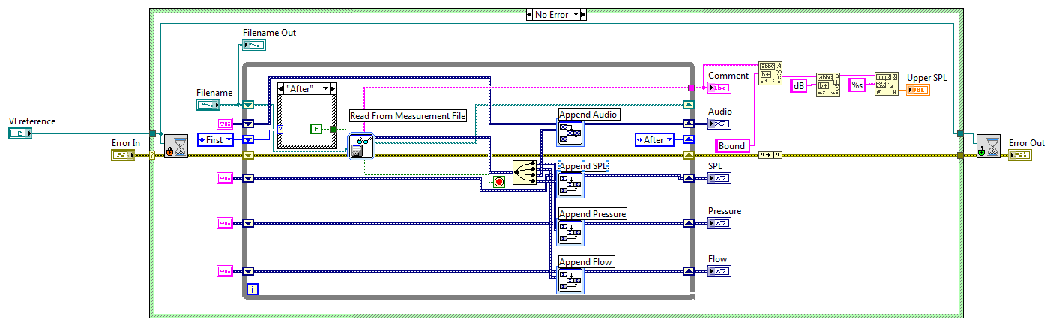You should never have to see the front panel of this SubVI since it will run in the background. Let’s just focus on the block diagram (You will see something similar in the Booth Analysis section).

After setting the cursor to busy, the program opens up the selected file spits the data into wires for each type (Pressure, Flow, Audio, SPL). Each chunk of data is read then appended to the next chunk through the full file. The comment is also read (SPL Bound).

#### Labial Pressure Marker

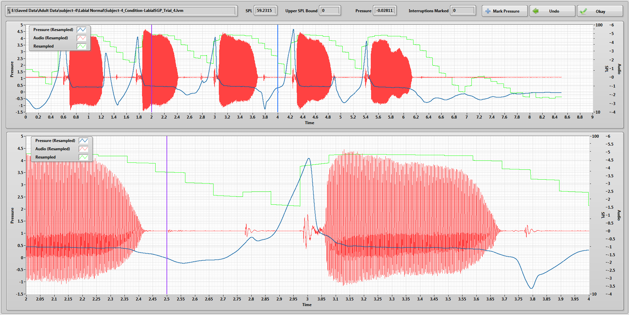In this SubVI, you will mark the pressures right before phonation. These are selected by moving the purple cursor in the bottom graph to the appropriate spot on the curve then clicking the Mark Pressure button. You can move the bounds of the bottom graph by moving the cursors on the top graph.

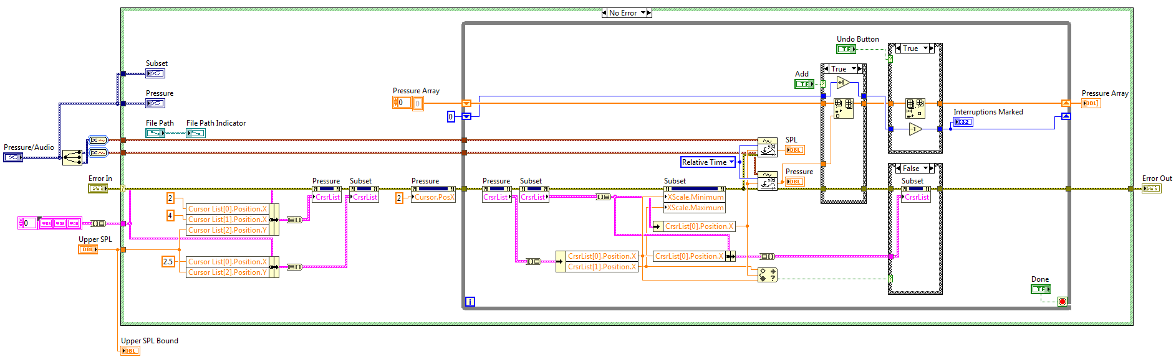There is an indicator for the number of pressures marked as well as an undo button if you make a mistake. Once finished, click Okay.

It works by monitoring the cursors through Cursor List property nodes and bundling/unbundling clusters. The starting positions are set before the while loop. If the bottom cursor ends up outside the bounds set by the upper cursors, it will be forced to a new position. When Mark or Undo are clicked, the pressure value at the x position of the bottom cursor is added (or removed) from an array.

#### MFR

In this SubVI, you want to find the mean flow rate. Where on the curve depends on the test you do. In general, you want to mark multiple sections where you know the subject is phonating. Like other SubVIs, the bottom graph is bound by the cursors on the upper graph.

The MFR SubVI works in a similar fashion as the Labial Pressure Marker. It monitors the cursor positions through clusters and property nodes and finds the average of the data between the cursors.

#### Mark Phonation Cutoff

Like the Labial Pressure Marker, you will control the bottom graph with the upper cursor and mark where phonation (acoustics trace) cuts off.

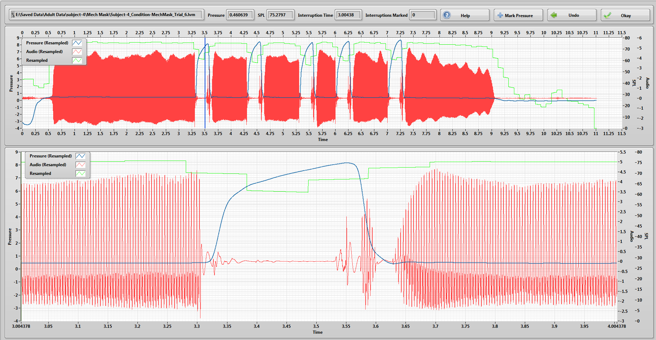Again, this works through using property nodes. I’ve mentioned these a lot. You should probably figure out what they do. There should be info in previous sections of this binder.

#### Find SGP and PTP

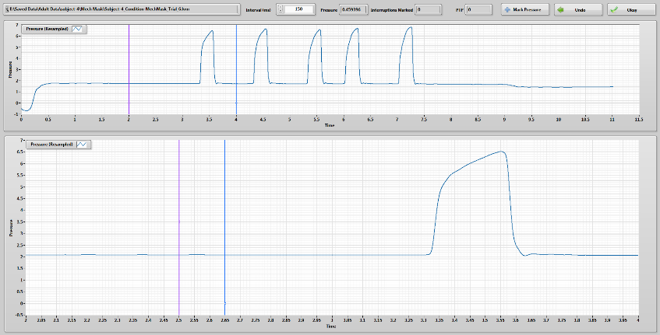For mechanical interruptions, you need both the pressure where phonation cuts off and SGP to calculate PTP. For these trials, SGP is assumed to be 150ms after the start of the interruption. So, in this SubVI, the left cursor is moveable and the right is set to move with it.

#### Pick one

This is a very simple SubVI that just waits until the user picks either “PTP” Or No PTP.” The user’s choice determines the SubVI that is called next. This is because the type of trial that was collected will need to be analyzed differently depending if you are looking for PTP (quite trail, similar to labial PTP) or not.

#### Pressure or Mark Phonation Cutoff

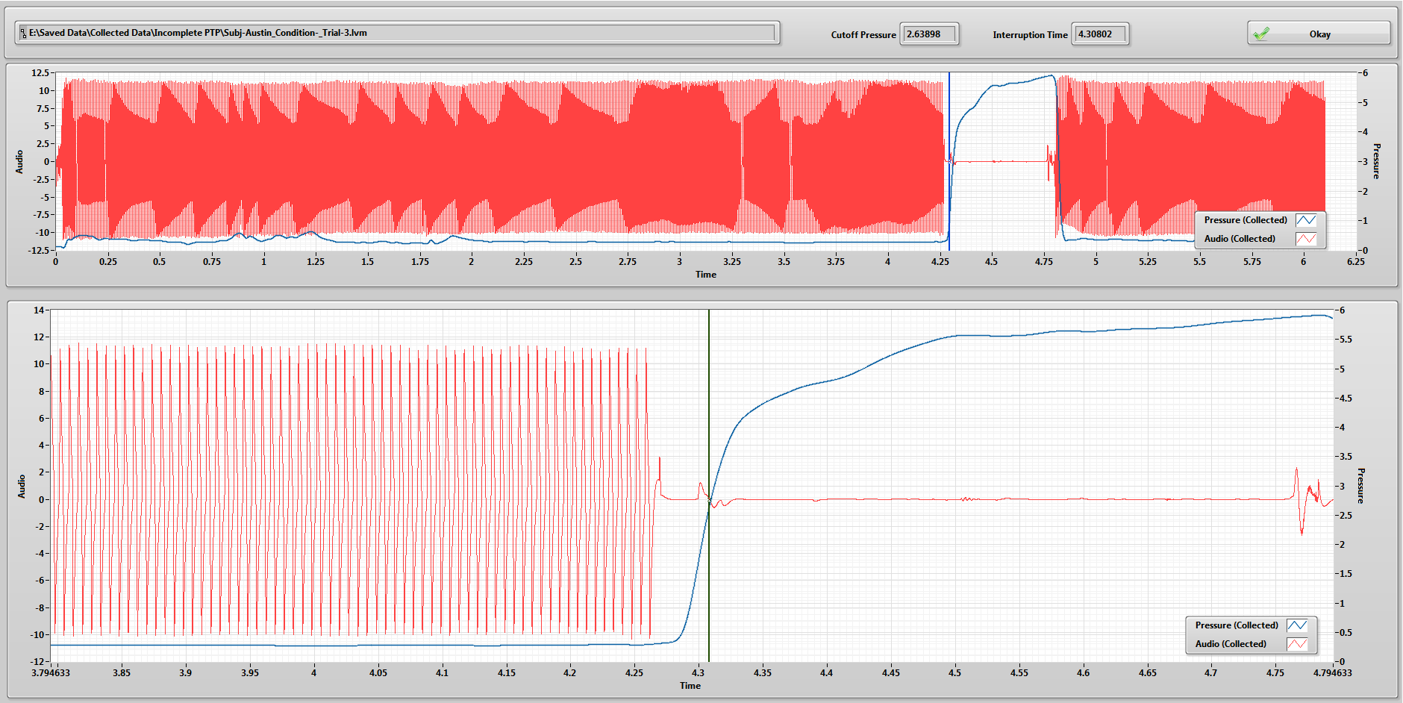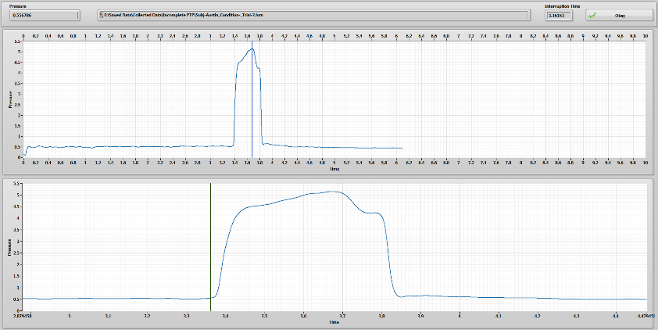In this SubVI, you will just be marking the time where the interruption starts. This is done by placing the cursor in right where the pressure starts to increase. As of writing this section, there will be only one interruption per trial. This may change in the future.

If you are looking for PTP, you will be prompted to mark where phonation is cutoff. If at some point in the future, multiple interruptions will be used, then this can be switched out with the Mark Phonation Cutoff SubVI used in the complete mechanical interruption analysis.

#### FLow

This SubVI is a little more complicated. The cursors on the upper-left graph control the bounds for the upper-right and bottom graphs. The red and green cursor positions are controlled from the upper-right graph. The upper-right graph displays the change in flow over time. You will use this to mark locations during the interruption where there is minimal change in flow. More details on this can be found in the Incomplete Interruption binder by Calvin Hedberg.

#### Max Pressure Find

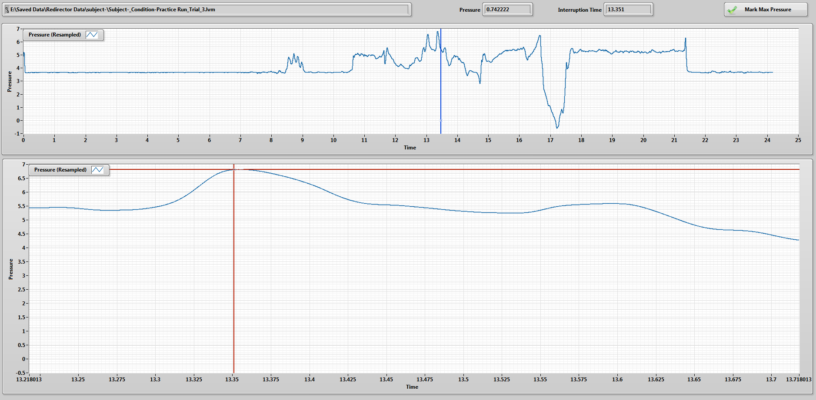Once again, similar to the other analysis programs, you will be marking a specific pressure. In this case, you will be marking where the pressure peaks during each trial. The basic principle is that the pressure in the tank will eventually equilibrate with SGP.

##### Final Notes

Some of these programs might be updated since my writing this. If you are confused on how something works, I (hopefully) have added more comments to help you. Right now, we are doing the most work on the complete interrupter, so its collection and analysis programs will be the most up-to-date. Look to those for templates and more information.